DSA0601 – DATA HANDLING AND VISUALIZATION
SET 2: CUSTOMER FEEDBACK ANALYSIS
Experiment: Data Visualization using R

Dataset: Customer Satisfaction
Customer ID | Age | Satisfaction Score
1 | 25 | 4
2 | 30 | 5
3 | 35 | 3
4 | 28 | 4
5 | 40 | 5

PROGRAM 1: Histogram of Customer Ages
Aim/Question: Create a histogram to represent the distribution of customer ages. Label the axes and title the chart.
Required Package(s): No additional package is required; hist() is available in base R.
R Code:
# Dataset
age <- c(25, 30, 35, 28, 40)
# Histogram
hist(age,
main = "Distribution of Customer Ages",
xlab = "Age",
ylab = "Frequency")
Code Explanation: The age values are stored in the age vector. hist() creates the histogram, while main, xlab, and ylab provide the title and axis labels.
Expected Output: A histogram showing the distribution of the five customer ages.
Observation: The histogram represents the distribution of the five customer ages in the given dataset.
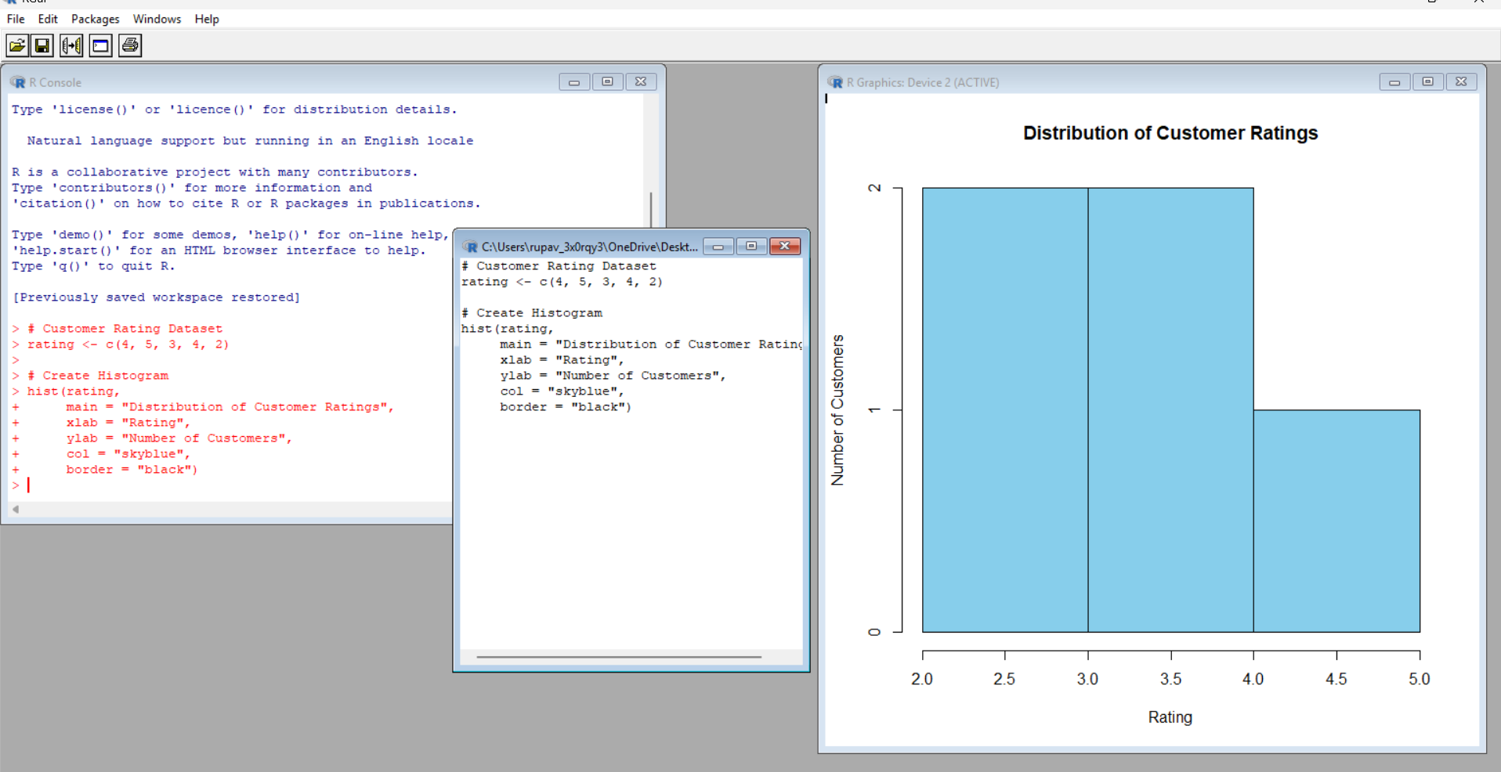

PROGRAM 2: Pie Chart of Satisfaction Scores
Aim/Question: Generate a pie chart to display the overall distribution of customer satisfaction scores and include labels.
Required Package(s): No additional package is required; table() and pie() are available in base R.
R Code:
# Satisfaction scores
satisfaction <- c(4, 5, 3, 4, 5)
# Calculate frequency
score_count <- table(satisfaction)
# Pie Chart
pie(score_count,
labels = paste(names(score_count), "Score"),
main = "Customer Satisfaction Scores")
Code Explanation: The satisfaction scores are stored in a vector. table() counts how many times each score occurs. pie() uses these frequencies to create the pie chart, and paste() creates labels such as 3 Score, 4 Score, and 5 Score.
Expected Output: A pie chart showing the frequency distribution of satisfaction scores 3, 4, and 5.
Observation: Scores 4 and 5 each occur twice, while score 3 occurs once.
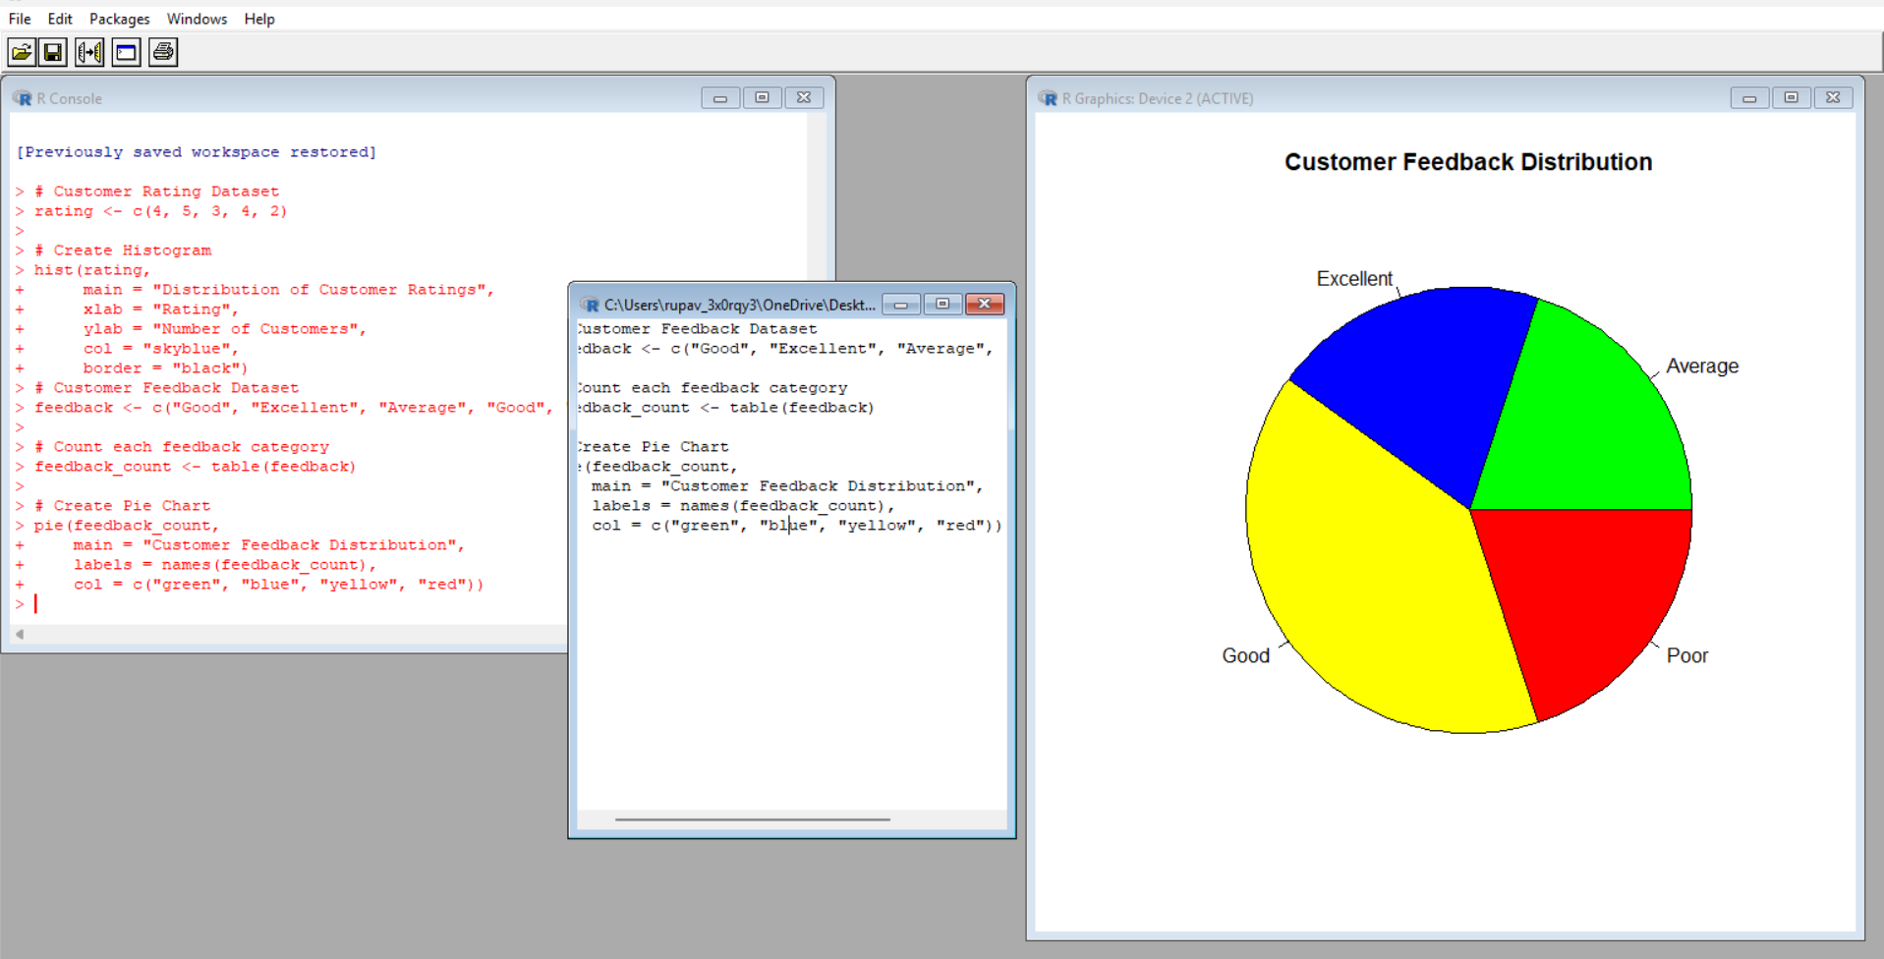

PROGRAM 3: Stacked Bar Chart by Age Group
Aim/Question: Build a stacked bar chart to visualize the distribution of customer satisfaction scores by age group.
Required Package(s): No additional package is required; cut(), table(), and barplot() are available in base R.
R Code:
# Dataset
age <- c(25, 30, 35, 28, 40)
satisfaction <- c(4, 5, 3, 4, 5)
# Create age groups
age_group <- cut(age,
breaks = c(20, 29, 39, 49),
labels = c("20-29", "30-39", "40-49"))
# Create table
data <- table(age_group, satisfaction)
# Stacked Bar Chart
barplot(data,
beside = FALSE,
main = "Satisfaction Scores by Age Group",
xlab = "Age Group",
ylab = "Number of Customers",
legend.text = TRUE)
Code Explanation: cut() divides the customer ages into the three required age groups. table() creates a frequency table of age groups against satisfaction scores. barplot() displays the table as a stacked bar chart because beside = FALSE. legend.text = TRUE displays the satisfaction-score legend.
Expected Output: A stacked bar chart with the age groups 20-29, 30-39, and 40-49, showing the corresponding satisfaction-score frequencies.
Observation: The code creates three age groups and stacks the satisfaction-score frequencies for each group.
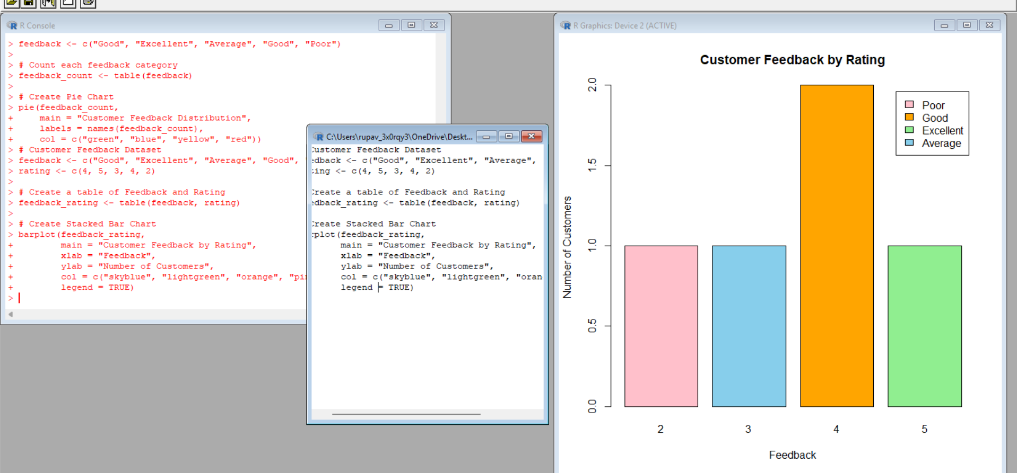

PROGRAM 4: Word Cloud of Customer Feedback
Aim/Question: Develop a word cloud from open-ended customer feedback to identify prevalent customer sentiments.
Required Package(s): wordcloud and RColorBrewer.
R Code:
# Install packages if required
# install.packages("wordcloud")
# install.packages("RColorBrewer")
library(wordcloud)
library(RColorBrewer)
feedback <- c(
"good service",
"excellent service",
"good experience",
"friendly staff",
"excellent service"
)
# Convert feedback to lowercase and split into words
words <- unlist(strsplit(tolower(feedback), " "))
# Count word frequency
word_count <- table(words)
# Word Cloud
wordcloud(names(word_count),
freq = word_count,
min.freq = 1,
scale = c(3, 0.5),
colors = brewer.pal(8, "Dark2"),
random.order = FALSE)
Code Explanation: The feedback vector contains the five supplied feedback sentences. tolower() converts the text to lowercase. strsplit() separates each sentence into individual words, and unlist() combines the resulting words. table() counts each word. wordcloud() visualizes the words according to their frequencies.
Expected Output: A word cloud displaying the frequently occurring words from the supplied feedback, including service, excellent, good, friendly, and experience.
Observation: The word cloud highlights frequently occurring terms in the supplied sample feedback, including service, excellent, good, friendly, and experience.

PROCEDURE
1. Create vectors for customer age and satisfaction score.
2. Use hist() to represent the distribution of customer ages.
3. Use table() and pie() to display the satisfaction score distribution.
4. Create age groups using cut(), form a frequency table, and use barplot() for the stacked bar chart.
5. Prepare the supplied open-ended feedback text, convert it to lowercase, split it into words, and count the word frequencies.
6. Load the wordcloud and RColorBrewer packages and use wordcloud() to visualize frequent terms.

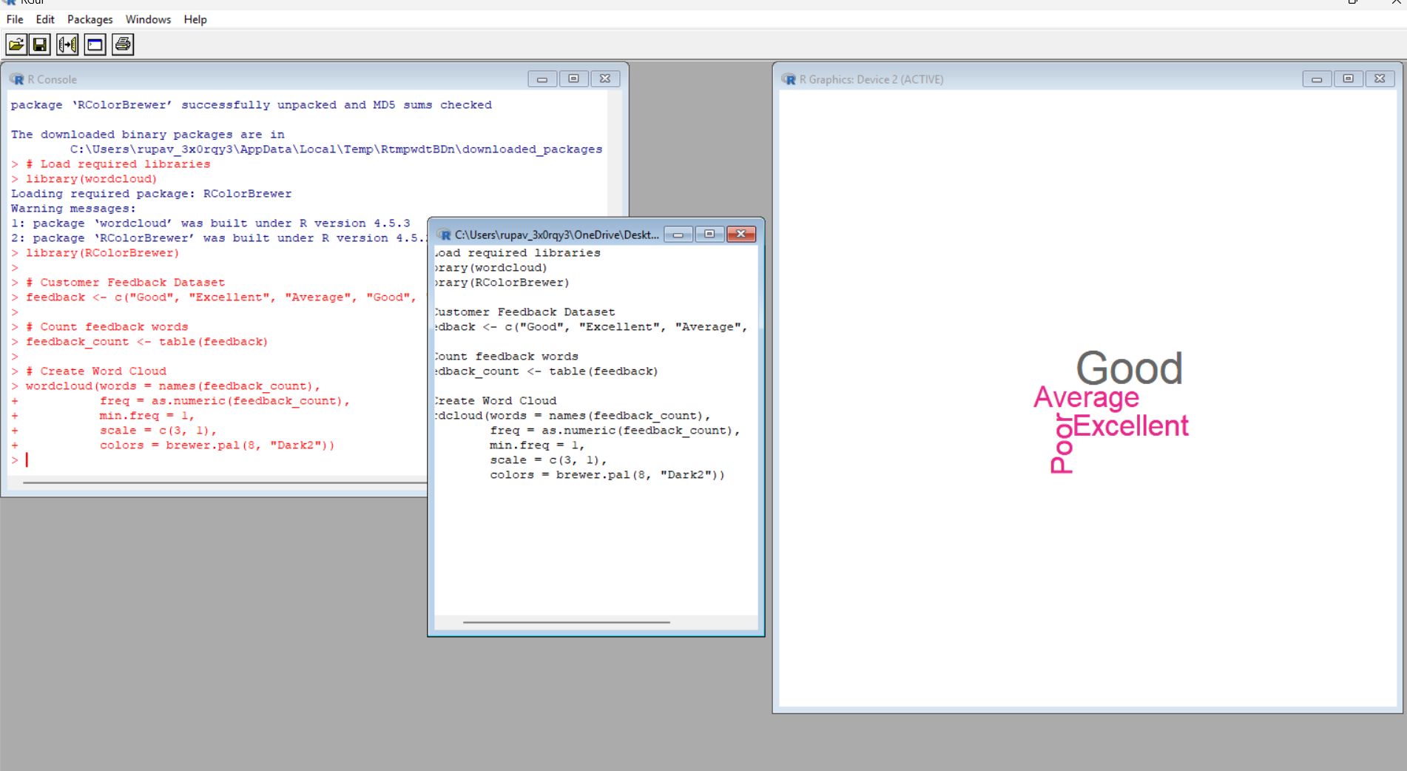

RESULT
The customer satisfaction data was successfully visualized using a histogram, pie chart, stacked bar chart, and word cloud.

KEY R FUNCTIONS USED
Function | Purpose
hist() | Creates a histogram.
table() | Calculates frequency counts and creates contingency tables.
pie() | Creates a pie chart.
cut() | Divides numeric values into specified groups or intervals.
barplot() | Creates bar and stacked bar charts.
strsplit() | Splits text into individual words.
tolower() | Converts text to lowercase.
wordcloud() | Creates a word cloud from words and their frequencies.

REQUIRED PACKAGES
• wordcloud – used to generate the word cloud.
• RColorBrewer – used to provide the word-cloud color palette.

